**On Board S- Band Patch Antenna Selection**

The following key features were considered when selecting a preliminary Patch antenna:

* center frequency gain
* beam width
* mass

Center frequency gain was the most important consideration since it contributes to the power at the receiving antenna, which effects the Signal to Noise numerator of our system and thus, directly effects the data rate. Beam width and mass were treated more as limitations, since we were given maximum pointing requirements and a mass budget from respective subsystems. Table 1: Summary of S-Band patch antennas key features

|  |  |  |  |  |
| --- | --- | --- | --- | --- |
| Company | Center frequency gain (dBi) | Beam Width (deg) | Mass (g) | Website |
| EnduroSat | 8.3 | 71 | 64 | https://www.endurosat.com/products/cubesat-s-band-patch-antenna/ |
| NanoAvionics | 6 | 40 | 49 | https://n-avionics.com/subsystems/cubesat-s-band-patch-antenna/ |
| CubeSatShop | 6 | 85 | 72 | https://www.cubesatshop.com/product/s-band-patch-antenna-rhcp-hispico/ |

The selected Patch antenna is the Cubesat S-band Patch Antenna made by EnduroSat. This antenna was chosen over other candidates mainly for its superior center frequency gain.. With this antenna selected, the total mass of the transceiver and antenna comes out to 254 g. When comparing total mass to our allotted mass budget (5% of 3.6g=180g), It appears this selection oversteps our budget. However, after discussion with a member of the structural team, it has been decided that this mass overshoot is justified, since the currently selected parts in the model puts the mass of the CubeSat well below 3.6 kg.

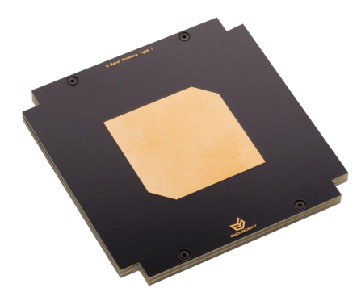

Figure 1: Top Side

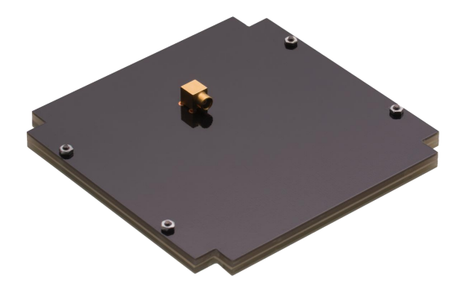

Figure 2: Bottom Side

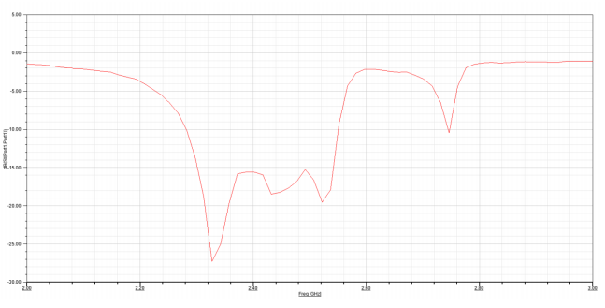

Figure 3: Measured Return Loss of Antenna